Creating A Log in Link for LinkedIn.

Zphisher

Press 14 using the Linkedin

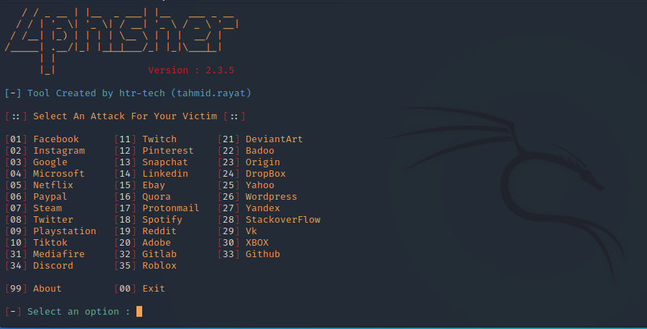

Press 2 for Cloudflare

No custom port

Do not mask URL it does not work just use default URL mask

Once you have your URL create a new terminal

Cd social-engineer-toolkit

Ls

Sudo ./setoolkit

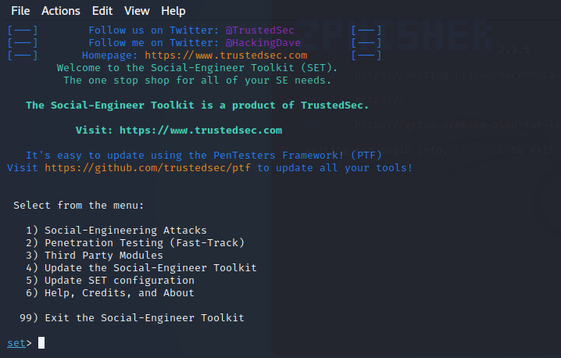

Press 1 to social-engineering attack

Press 5 to Mass Mailer attack

Press 2 for Email Attack Mass Mailer

I created my own text with a bunch of emails.

Press 2 for One time use email template

Using the subject

Send the message as plain

Body of the message

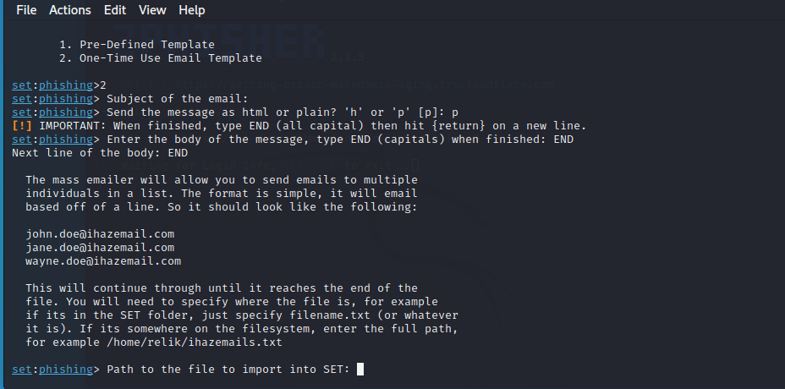

File path to your imported emails.

Press 1 for your own Gmail

Then your password emails the one from google app not from you’re the password of your email.

Flag it as high priority

n for no attach a file

n for no inline file

and it will automatically send it.

